# Spring 2021 MTH301: Calculus II

# Assignment No. 2 (Lectures # 31 to 34) Total Marks: 20

# Due Date: 09-08- 2021

**Please read the following instructions before attempting the solution of this assignment:**

* To solve this assignment, you should have good command over 31 to 34 lectures.
* Try to consolidate your concepts that you learn in the lectures with these questions.
* Upload assignments properly through VULMS. No Assignment will be accepted through Email.
* No assignment will be accepted after the due date.
* Write your ID on the top of your solution file.
* All students are directed to use the font and style of text as is used in this document.
* Use MathType or Equation Editor etc. for mathematical symbols and equations.
* Remember that you are supposed to submit your assignment in MS-Word format any other format like scanned, images, MS-Excel, HTML etc. will not be accepted.
* Do not use colorful backgrounds in your solution files.
* This is an individual assignment (not a group assignment). So keep in mind that you are supposed to submit your own, self-made and different assignment even if you discuss the questions with your class fellows. All similar assignments (even with some meaningless modifications) will be awarded zero marks and no excuse will be accepted. This is your responsibility to keep your assignment safe from others.

**Question No.1 Marks: 10**

Use Green’s Theorem to evaluate the line integral

$I=\oint{\left(7y^{2}-6x\right)dy-(yx^{2}+x)}dx$ 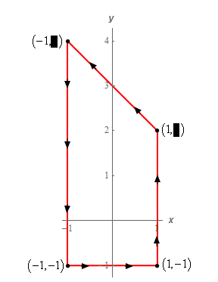

round the region bounded by

$$-1<y<4-x$$

Find x limits from this graph and then evaluate the given line integral.

**Question No.2 Marks: 10**

Find the work done in moving a particle with a force field $F=3x^{2}i+\left(2xz-y\right)j+zk$ along the curve $x^{2}=4y$ and $3x^{3}=8z$ from $x=0$ to $x=2$.